Petty Politics – 2 Players

Created by: Jennifer Assid

# Objective of the Game

Be the first player to clear all cards from their three task decks.

# Set-Up

***\*\*\* The board has already been set up for you online. This is here to reference the terms used within the rules and how those translate to the positions on the table\*\*\****

# Filling your Hands

1. Graphical user interface, diagram

   Description automatically generatedSet up the table as shown in the picture above
   1. Remove all face cards (leave the Aces) and Jokers from two decks, saving one King, Queen, Jack, and Joker for each deck

(total of 2 Kings, 2 Queens, 2 Jacks, and 2 Jokers)

* 1. One joker per **Joker’s Sleeve**
  2. King, Queen, and Jack in each **Order** deck.
  3. Place one deck in **Knight’s Deck** and one deck in **Mage’s Deck**.

1. **Deal** 8 cards from your **Deck** into each of your **Task Decks** (total of 24 cards), leaving 16 cards in each **Deck**.

# Assigning Order

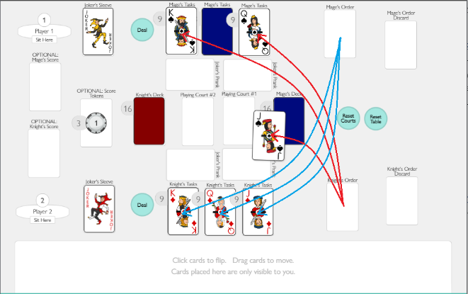What is **Order**? **Order** determines the order in which a player must clear their three **Task Decks**. The **Task Deck** with the Jack placed on top will be the first task deck cleared, the Queen the second, and King the third.

1. Look at the top three cards of each of the opposing player’s **Task Decks**. Once both players are satisfied, restore the **Task Decks**.
2. Place the cards in your **Order** holder in the opposing player’s task decks, face up, assigning their **Order**.

# How to Play

All **bolded terms** refer to a spot / item on the playing table.

1. Pull the **Task Deck** with the Jack card placed on top into your hand and remove the face card from the hand into your **Order Discard** holder.

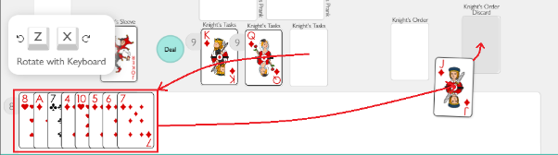

1. Place a card facedown from your **Deck** pile into the **Playing Court** immediately adjacent. When both players are ready, click the card you placed into **the Playing Court** to flip it over.

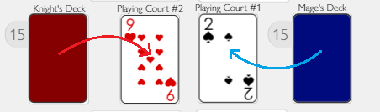

1. 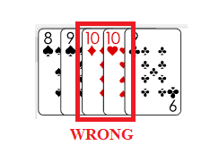Both players now work to clear the cards in their hand by counting either up or down from the top cards within the **Playing Courts**
   1. Players can play on either **Playing Court**

(see “*What is the Joker’s Prank”* for an exception)

* 1. 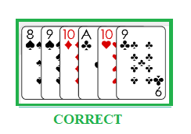No repeating numbers on one **Playing Court** (i.e. 10 on 10)
  2. Ace loops back to 2; 2 loops up to Ace.
     1. (ex. 9 -> 10 -> Ace -> 2 -> Ace -> 10 -> 9)
  3. If both players go to place a card on the same **Playing Court**, whichever card was there first stays and the other is removed.

1. When one player has no cards in their hand, the round has ended!
   1. The player who still has cards in their hand can enact the **Joker’s Prank**

(See “What is the Joker’s Prank?” section).

* 1. The player who cleared their hand goes to **Reset Courts**.
  2. Each player then pulls the next **Task Deck** into their hand and repeat steps 3-4.

If neither player can place cards in the **Playing Court**s, repeat steps 3-4 again.

If one **Deck** runs out of cards, both the players pause, **Reset Courts**, and return to Step 3.

(To **Reset Courts** is when you take all the cards in the Playing Courts, shuffle them together, and separate them evenly across the **Decks**.)

# How to Win

The person who clears all the cards from their **Task Decks** wins!

To play again, **Reset** the **Table** and start from Step 1.

***Reset Table*** *is when all cards are returned to the Decks (make sure to separate the two playing card decks from one another)*

# What is the Joker’s Prank?

The **Joker’s Prank** is when your Joker is placed within either **Joker’s Pranks** on your side of the board.

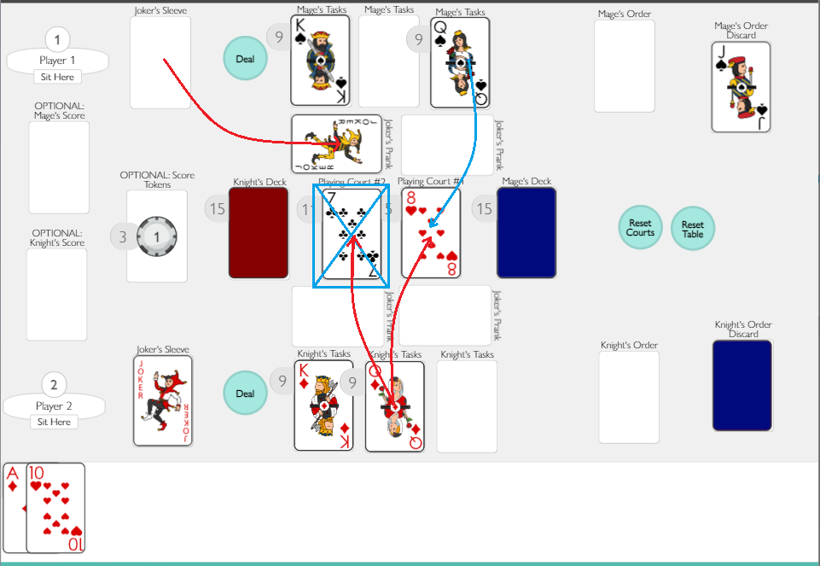 To enact the **Joker’s Prank**, place the opposing player’s Joker into one of their **Joker’s Prank** spots.

When a **Joker’s Prank** is active, the person being pranked CANNOT place any cards on that associated Playing Court until the **Joker’s Prank** has been removed. (Example: If the Knight’s Joker’s Prank is on the right side of the board, they cannot place cards in Playing Court #1 until the block has been removed)

Only one **Joker’s Prank** can be active on the board! Whenever a new block is introduced on either side of the board, if there are any existing blocks, they must be removed to their **Joker’s Sleeve**.